**WEEK 1 ASSIGNMENTS:- DAY 1**

1. Click the get data option in home tab and upload the specific dataset file in BI desktop.
2. After upload the dataset we can load or transform the data(For remove null value).

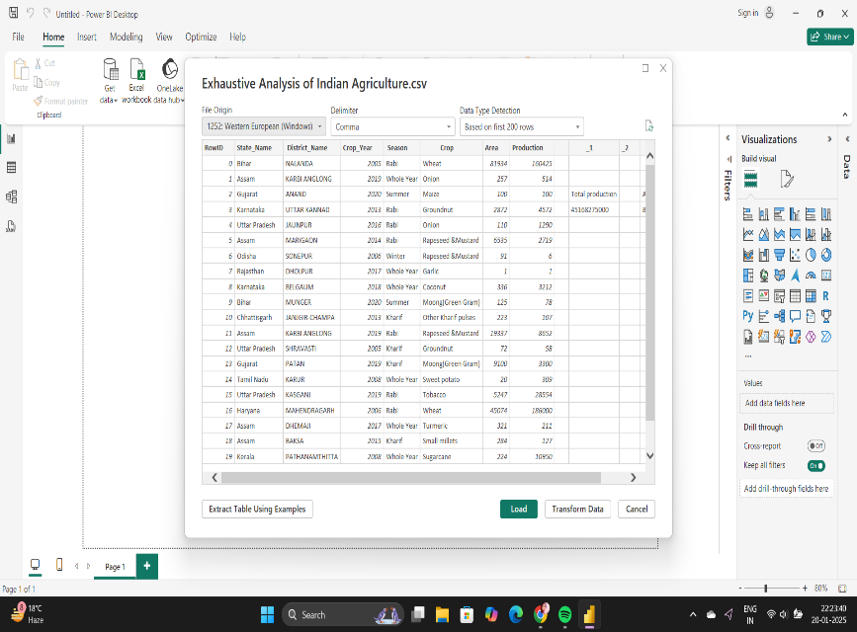

1. After Clicking the Load Option it takes some time to load the Data.

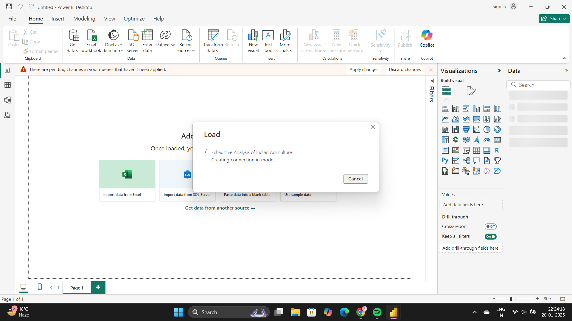

1. After Load the Data The Canvas is Look in the following:

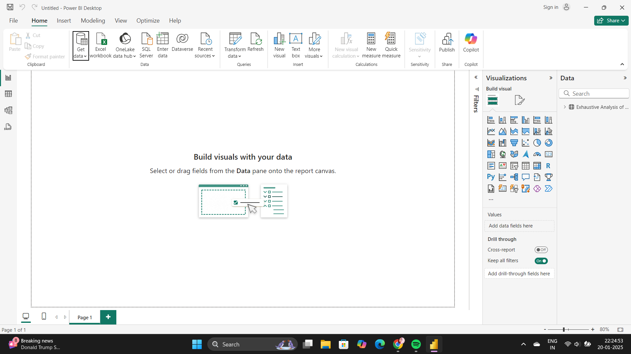

1. Then click The Table view tab to check what data is present inside the uploaded dataset.

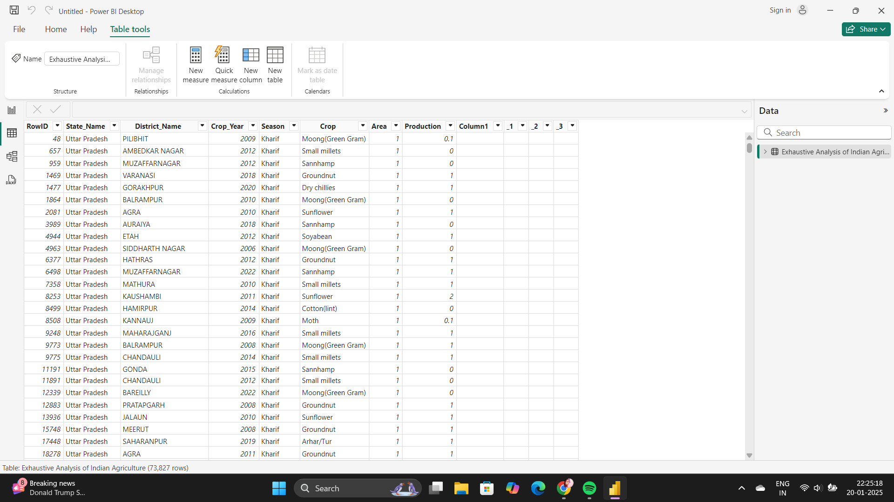

1. Then we transform the dataset by click the transform data inside the Home ribbon.

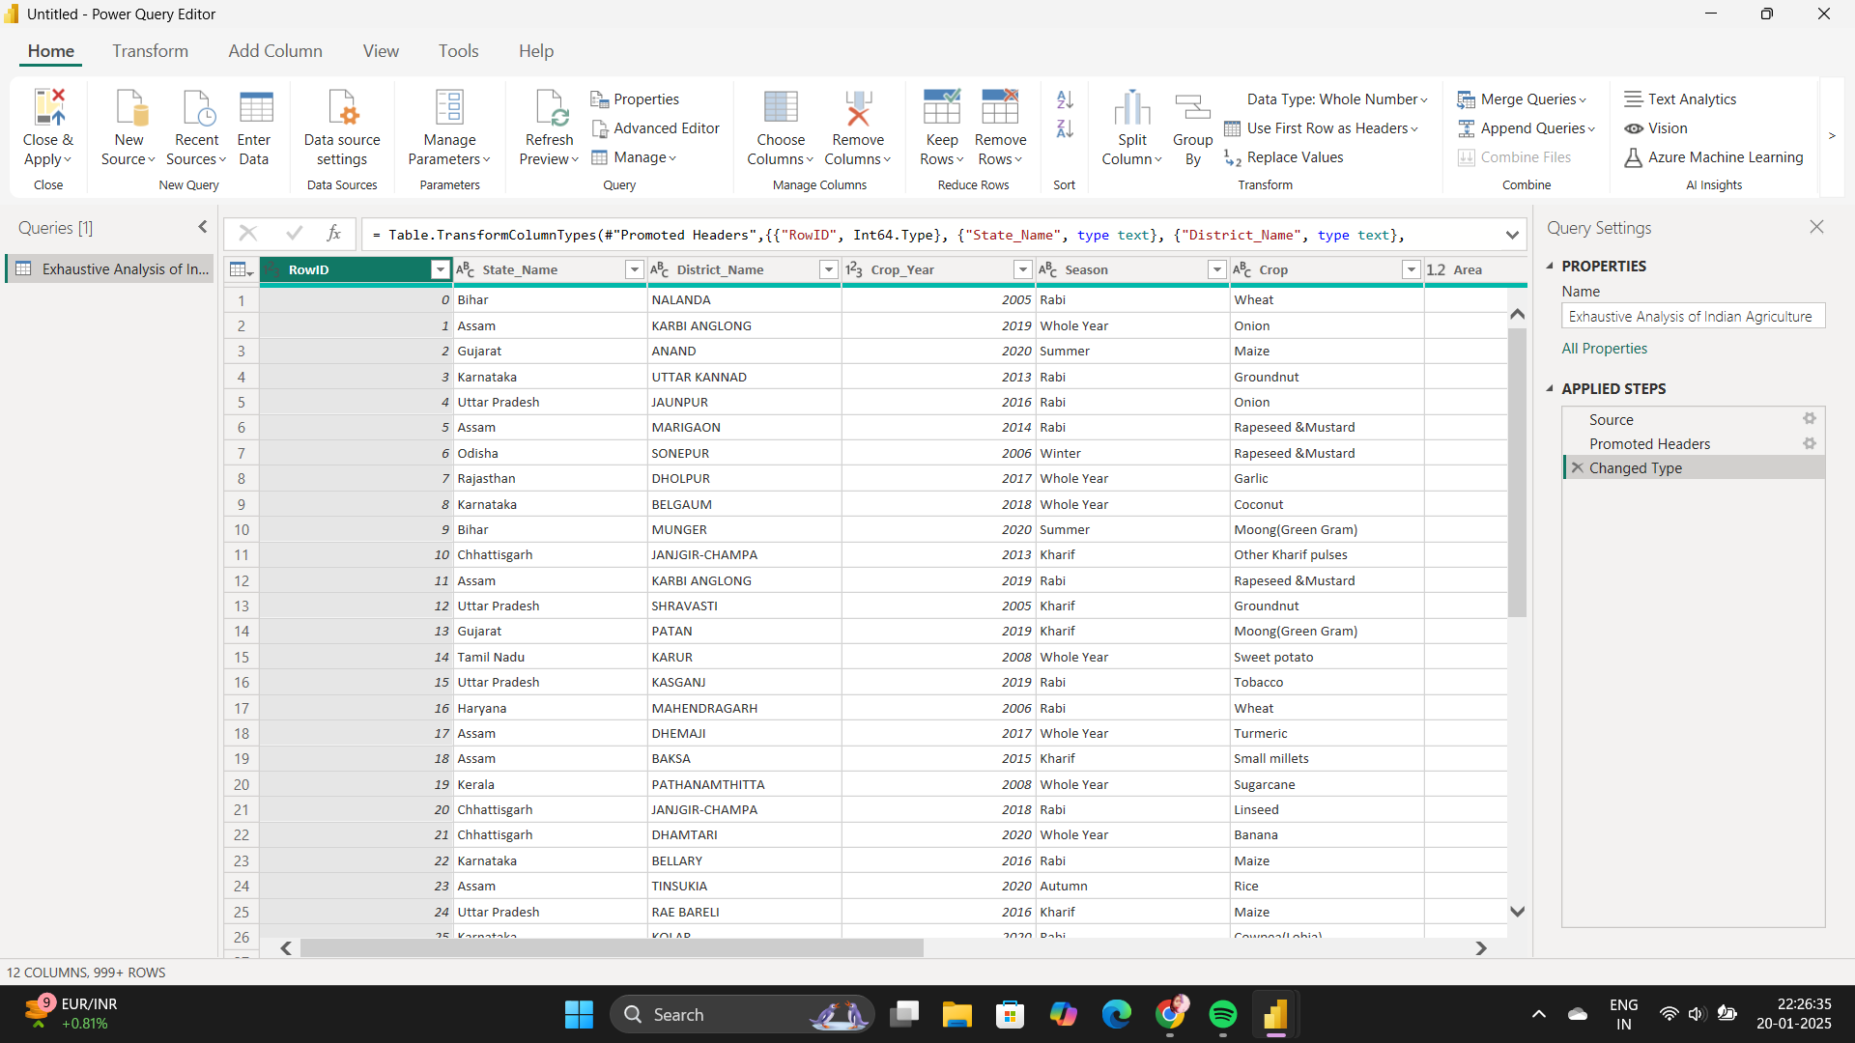

1. Then we remove the unnecessary columns by clicking remove column option .

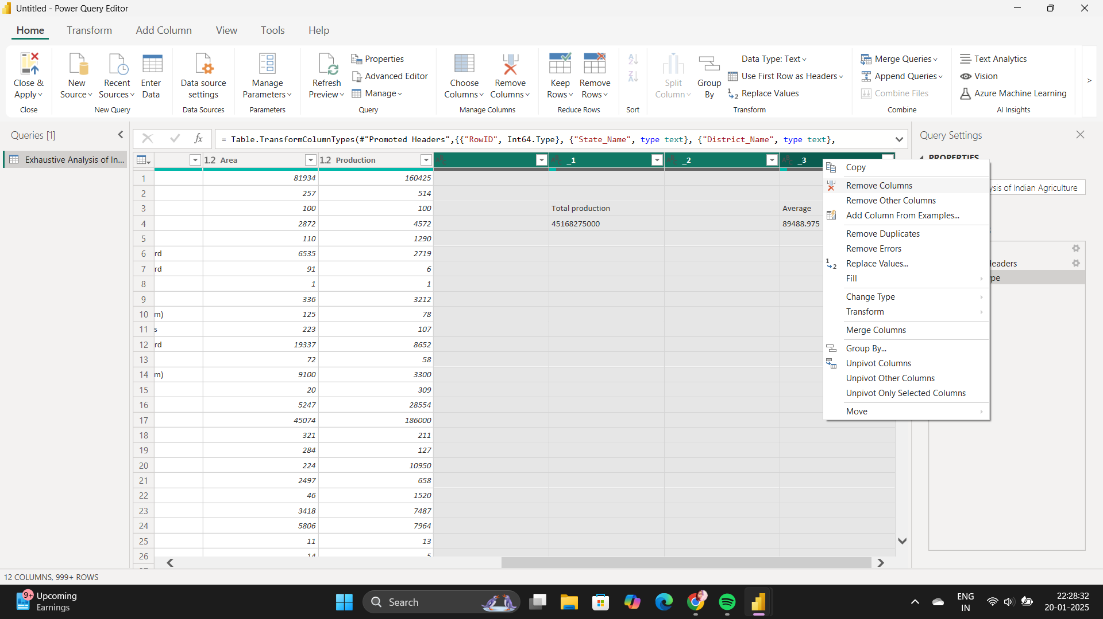

1. After Removing the Unnecessary columns we check the null values and error values in the view tab by click the column quality option.

